**Assignment – 1 :**

**query the movies collection to**

**1. get all documents**

**2. get all documents with writer set to "Quentin Tarantino"**

**3. get all documents where actors include "Brad Pitt"**

**4. get all documents with franchise set to "The Hobbit"**

**5. get all movies released in the 90s**

**6. get all movies released before the year 2000 or after 2010**

**1.**

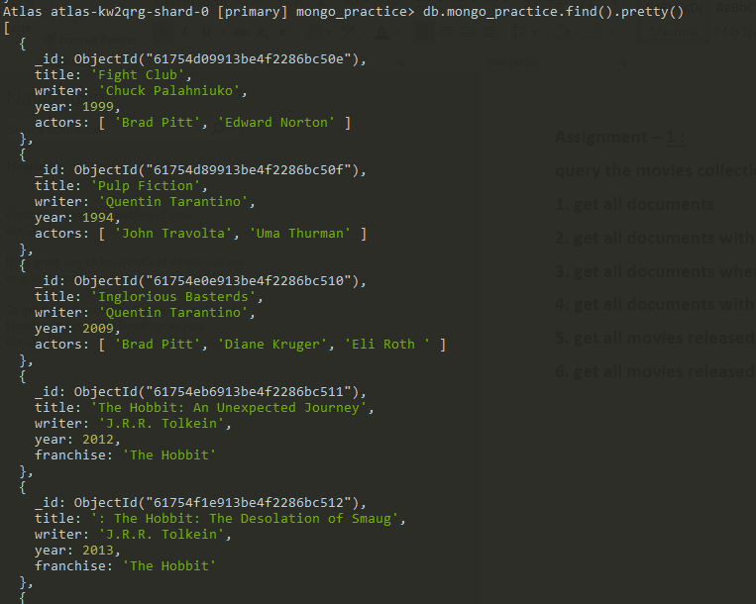

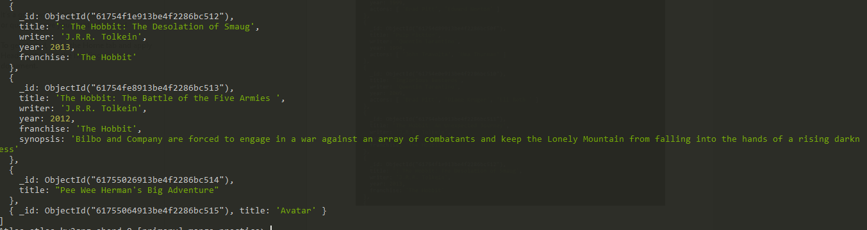

**2.**

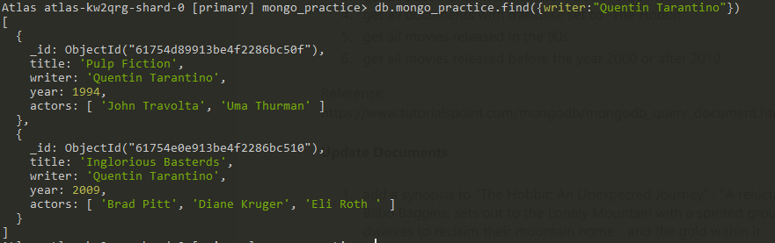

**3.**

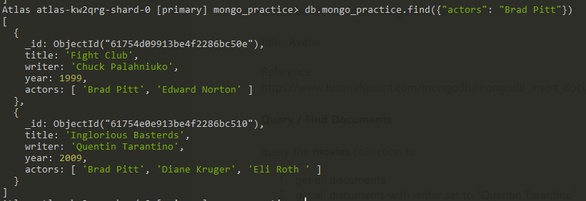

**4.**

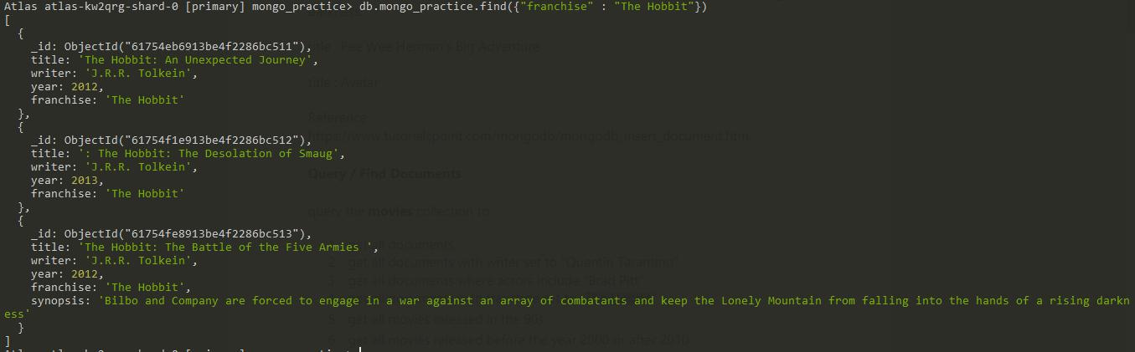

**5.**

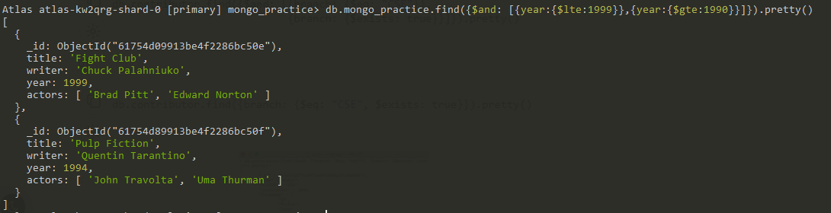

**6.**

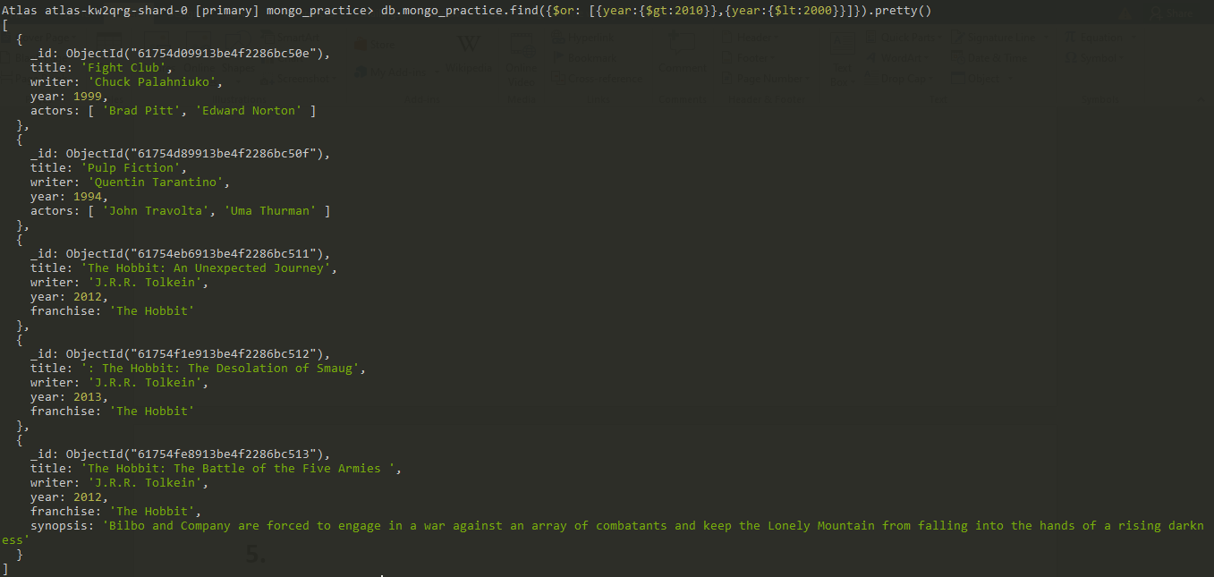

**Update Document:**

**1.**

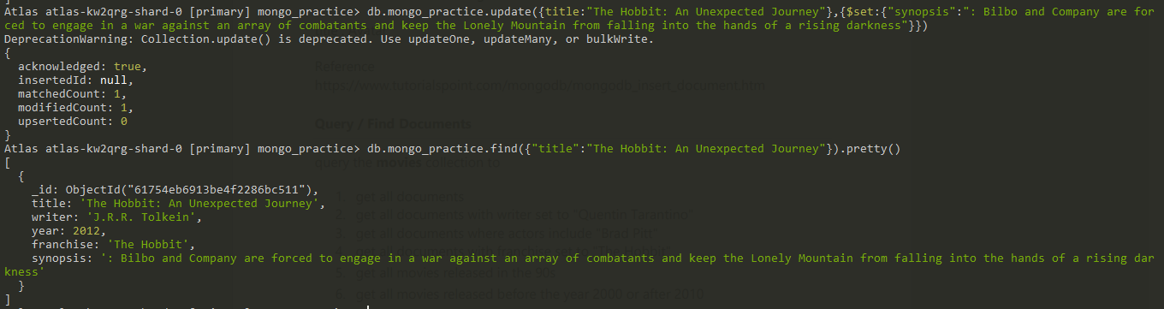

**2.**

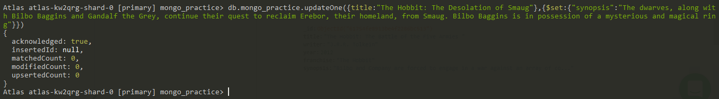

**3.**

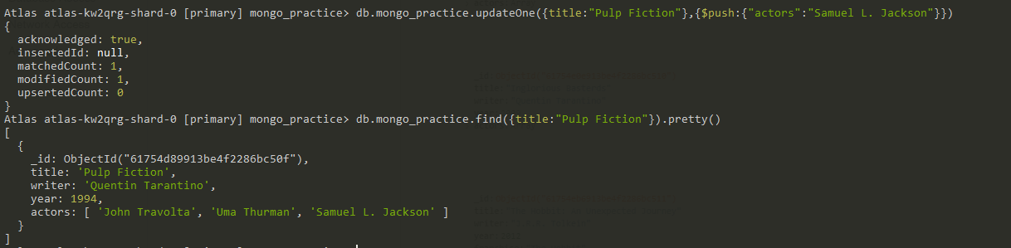

**3 Text Search :**

1. find all movies that have a synopsis that contains the word "Bilbo"

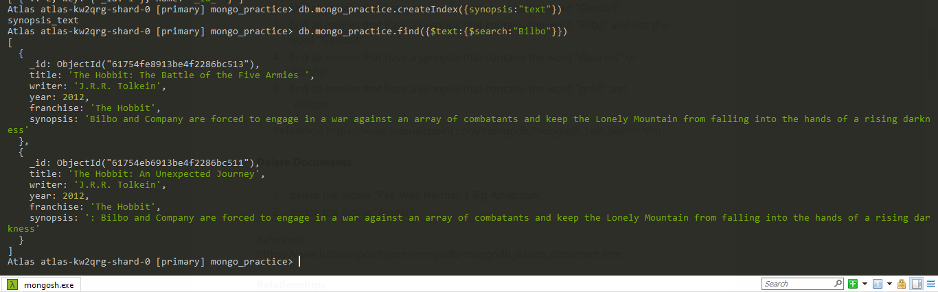

1. find all movies that have a synopsis that contains the word "Gandalf"

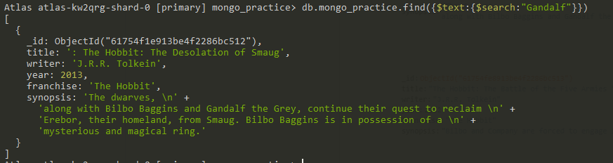

1. find all movies that have a synopsis that contains the word "Bilbo" and not the word "Gandalf"

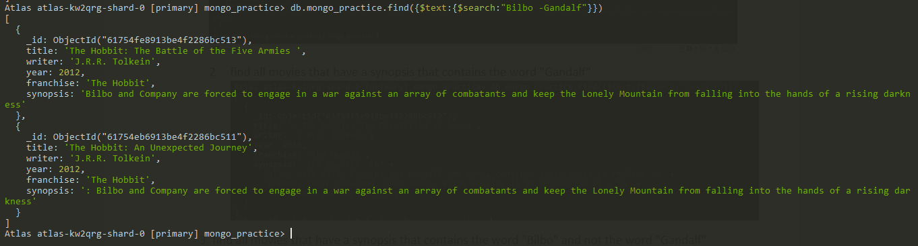

1. find all movies that have a synopsis that contains the word "dwarves" or "hobbit".

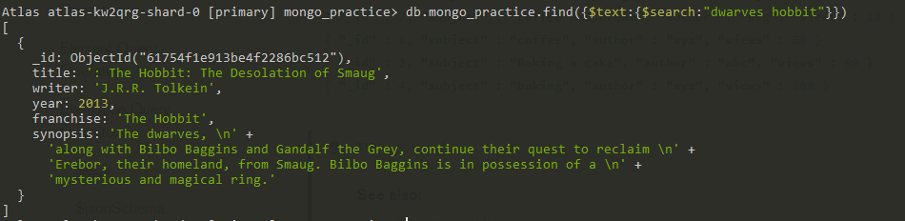

1. find all movies that have a synopsis that contains the word "gold" and "dragon"

**4 . Delete :**

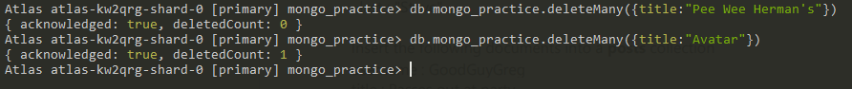

Relationships

Insert the following documents into a users collection

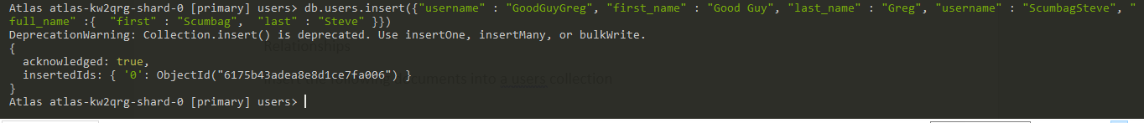

Insert the following documents into a posts collection

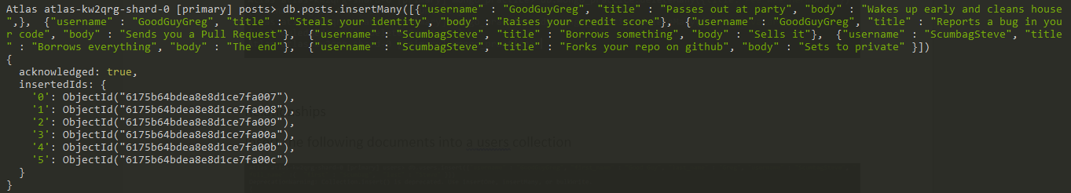

Insert the following documents into a comments collection

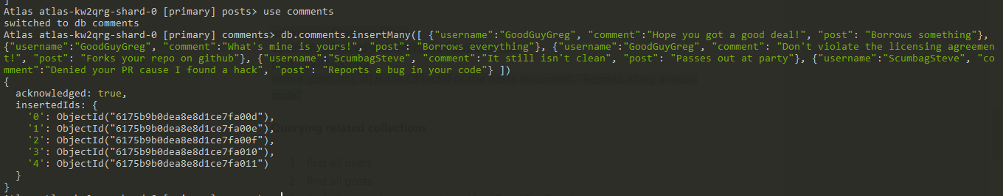

Querying related collections

1. find all users

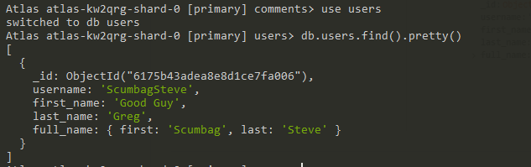

1. find all posts

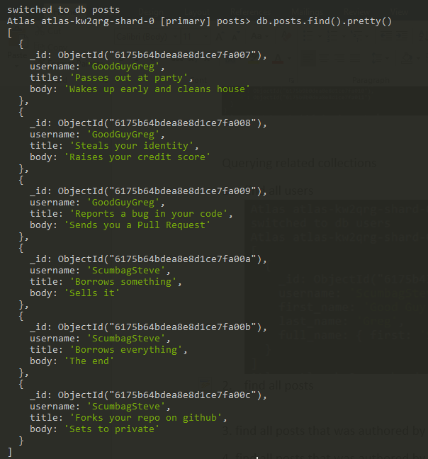

1. find all posts that was authored by "GoodGuyGreg"

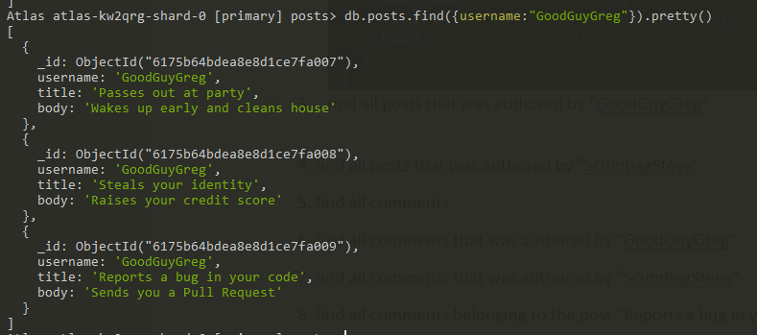

1. find all posts that was authored by "ScumbagSteve"

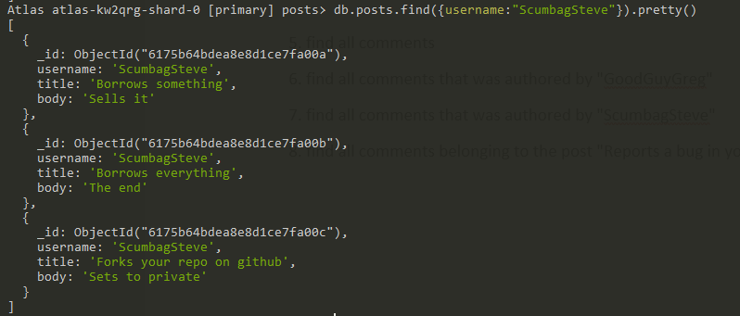

1. find all comments

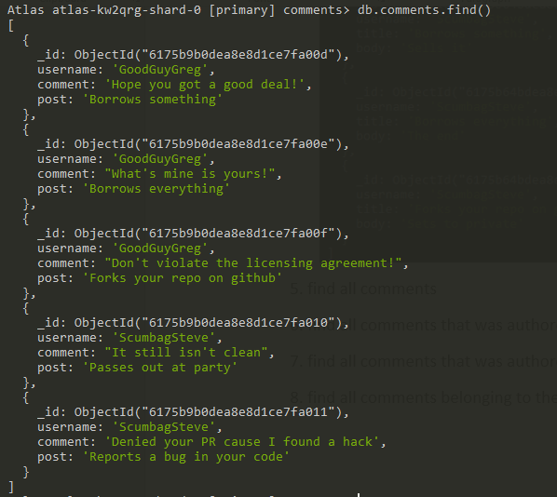

1. find all comments that was authored by "GoodGuyGreg"

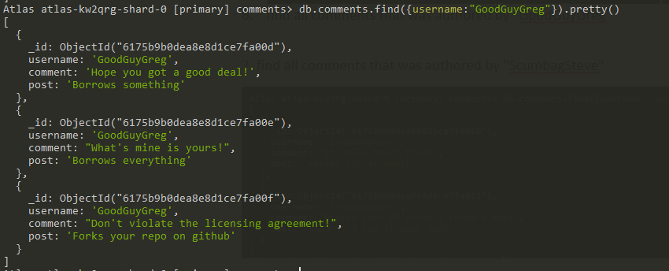

7. find all comments that was authored by "ScumbagSteve"

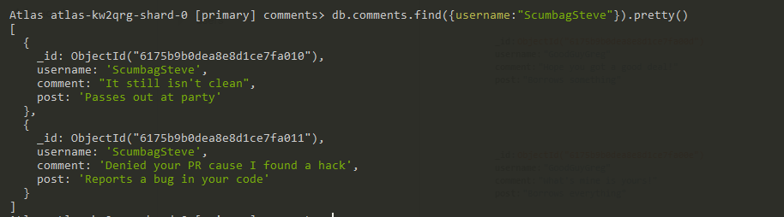

1. find all comments belonging to the post "Reports a bug in your code"

